**BRIEF REPORT**

How many months ago did you last see your gastroenterologist? 3

**IBD ACTIVITY – CDAI/UCDAI**

|  |  |
| --- | --- |
| **Condition:** | **Crohn's disease with Irritable Bowel Syndrome** |
| Number of **years diagnosed** with IBD? | **9** |
| In the past 3 months my IBD has been: | **Sometimes active, giving me symptoms on some days (for instance 1-2 days / week)** |
| Over the past week, how **many bowel movements have you had on average per day**? | **4** |
| Over the past week, how many of your bowel movements have been **loose/watery stools on average per day?** | **3** |
| General well-being over the last week: | **Very poor** |
| Over the past week, my **rectal bleeding has been:** | **Streaks of blood** |
| Over the past week have you **taken any antidiarrheal medication?** | **Yes** |
| Have you experienced a **fever** over the past week? | **Yes** |
| Have you experienced an **abdominal mass/tenderness** over the last week? | **Yes** |
| Have you experienced **abdominal pain or cramping** over the last week? | **Moderate** |
| Please tick any **complications** you are currently experiencing. | **Nocturnal diarrhea, Inflammation of the skin (e.g., Erythema nodosum, Pyoderma gangrenosum)** |

**IBD ACTIVITY –**

**HOW DO THEY COMPARE TO THE LAST APPOINTMENT**

|  |  |
| --- | --- |
| Compared to your last visit to the gastroenterologist, how would you describe the status of your IBD **SYMPTOMS** now? | **71 /100 (Note: Higher scores indicate greater severity of symptoms)** |
| Compared to your last visit to the gastroenterologist, how would you describe the status of your **PAIN** now? | **70 /100 (Note: Higher scores indicate greater severity of symptoms)** |
| Compared to your last visit to the gastroenterologist, how would you describe any changes to the **FREQUENCY OF BOWEL MOVEMENTS** now? | **81 /100 (Note: Higher scores indicate greater severity of symptoms)** |

**MEDICATIONS**

|  |  |
| --- | --- |
| **Drug** | **Dosage:** |
| **Prednisolone** | **10mg oral daily** |
| **Mesalazine** | **2g daily rectal (foam/enema/suppository)** |
| **Not assessed** | **Not assessed** |
| **Not assessed** | **Not assessed** |
| **Other medications: Not assessed** | |

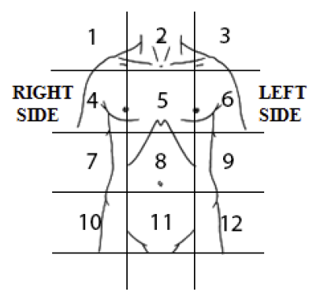 **PAIN SYMPTOMS**

|  |  |  |  |
| --- | --- | --- | --- |
| Location | Form of pain: | Duration of pain in last 24 hours | Rating of pain  (higher score  greater severity) |
| **8** | **Stabbing** | **5 hours** | **63 /100** |
| **11** | **Dull** | **4 hours** | **55 /100** |
| **Not assessed** | **Not assessed** | **Not assessed** | **Not assessed** |
| **Not assessed** | **Not assessed** | **Not assessed** | **Not assessed** |

**Patient questions/concerns**

|  |  |
| --- | --- |
| **Patient would like to talk about:** | **How do I get into remission? How long can I stay in remission?, The status of my IBD, Medication side-effects** |

**MENTAL HEALTH**

|  |  |
| --- | --- |
| Do you consider **hurting yourself, others, or feel suicidal?** | **No** |
| Are you currently are **CURRENTLY seeing a mental health professional?** | **No** |
| Do you have an appointment with a mental health expert within the next 14 days or willing to contact your local doctor (GP) if your mental health symptoms worsen? | **Yes** |
| K10 SCORE | **xx** |

**K10 SCORE INTERPRETATION:**

10-15 (Normal): Individuals tend to report minimal levels of psychological distress.

16-30 (Mild-moderate distress): Individuals tend to report some symptoms which may be associated with psychological distress.

31-50 (Severe distress): Individuals tend to report strong and frequent symptoms which may be associated with psychological distress.